Assignment 1: Check Eligibility to Vote

Write a JavaScript program that prompts the user to enter their age. The program should check if the entered age is greater than or equal to 18. If the age is greater than or equal to 18, display a message stating "You are eligible to vote." Otherwise, display a message stating "You are not eligible to vote yet."

Index.html

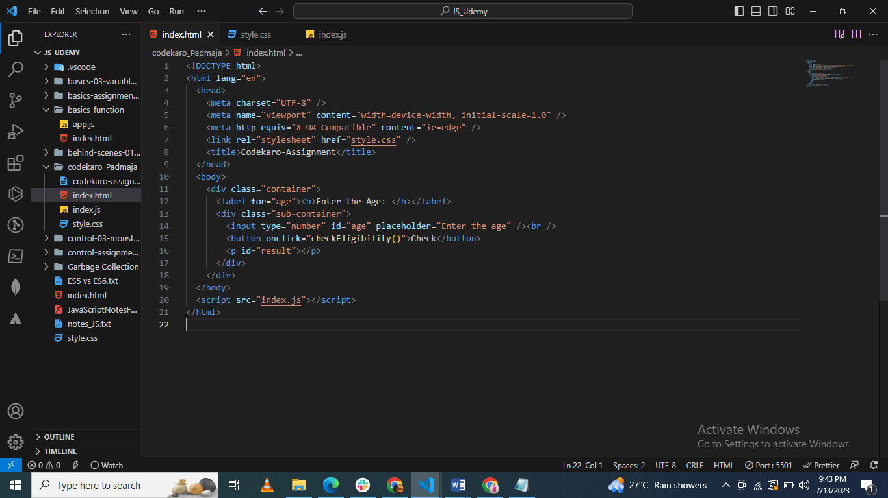

Style.css

body {

  display: flex;

  justify-content: center;

  align-items: center;

  height: 100vh;

}

.container {

  width: 500px;

  height: 300px;

  background-color: #f2f2f2;

  border: 1px solid white;

  padding: 20px;

  display:flex;

}

button {

  padding: 10px 20px;

  background-color: rgb(233, 95, 118);

  color: white;

  border: none;

  cursor: pointer;

  margin-top: 25px;

  text-align: center;

}

#result {

  font-weight: bold;

  margin-top: 20px;

}

Index.js

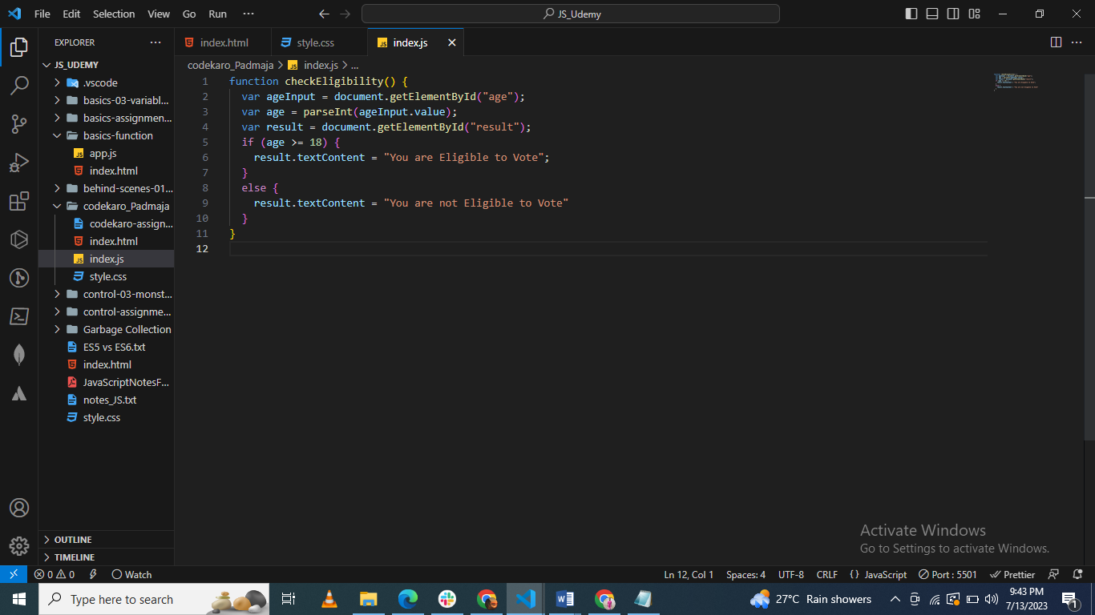

UI

